

**MAKE RANDOM SPARKLES USING SCRATCH**

**Getting started**

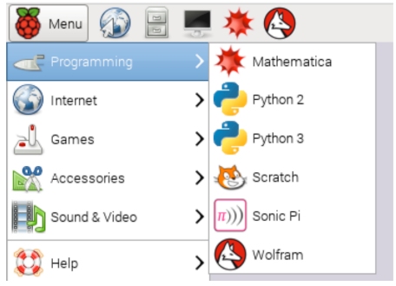 Start Scratch (1.4) from the Menu

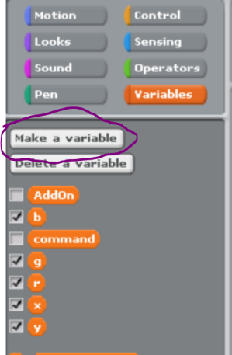

❖ Create necessary variables:  
**AddOn, command, r, g, b, x, y**

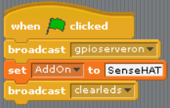 Start program (MAIN BLOCK) to  
tell Scratch youare using the   
gpioserver, SenseHat

and then clear all the dots

**Code to draw the Sparkles**

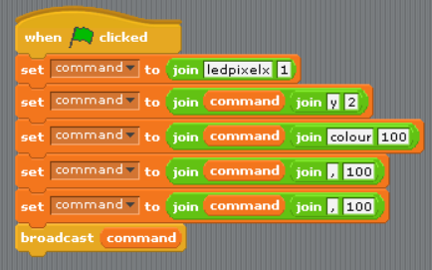 Start a new block (PIXEL BLOCK) with the code to draw one sparkle. This is a second block of code.

This creates a command that uses the values **x, y** to pick a dot and the values **r, g, b** to select a  
colour. **Be careful with all the green join blocks.**Click the green flag

❖ Have a play and try different **x, y, r, g, b** values. Then click the green flag to see the change

**You have now created the code to colour one dot. Fun, but wouldn’t it be better if you could colour ALL the dots. That is what you will do next.**

* 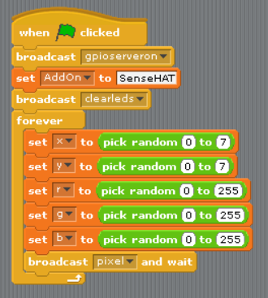Add the code to the MAIN BLOCK to pick random locations (x, y) and colours (**r, g, b**). Then send the command to draw the pixel to PIXEL BLOCK using broadcast. Make sure to add the [forever] so you get loads of sparkles.

**What if I love Red or Yellow or Green or Blue**

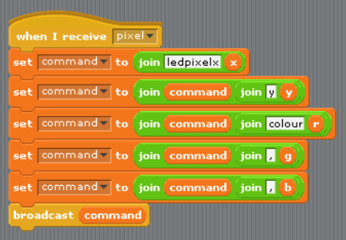 The last command is **[broadcast [pixel] and wait]**  
This is the command that tells the PIXEL BLOCK to draw  
the dot, so we need to change the first line in the  
PIXEL BLOCK to receive **[pixel]** code and include all the variables for x, y, r, g, b

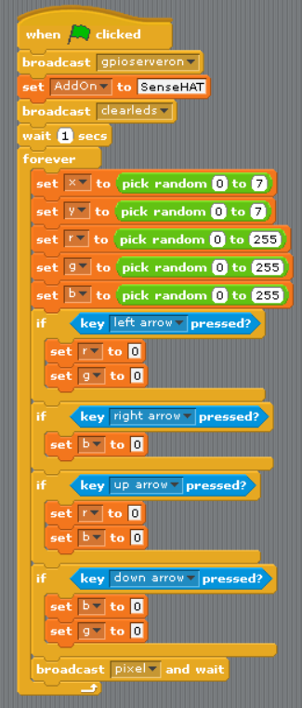 Add commands to make all the new dots red, yellow,  
green or blue

**Additional**

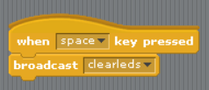 It’s all starting to look a bit busy. Wouldn’t it be great if you could clear the SenseHat with a press of the [spacebar]

**Challenges**

◆ Make it so there is always more red in the dots.

❖ Make it take more time between drawing the dots?